KHWOPA ENGINEERING COLLEGE
sECOND sEMESTER ASSESSMENT - 2015
lEVEL:- B. E. Computer/Second Semester
SUBJECT:- BEG123EL, Electrical Engineering
FULL MARKS:- 80
TIME:- 03:00 hrs. 2072-06-21 PASS MARKS:- 32

Candidates are required to give their answers in their own words as far as practicable.

Attempt any FIVE questions.
Q.1. a) State and Explain reciprocity theorem with an example. [5]
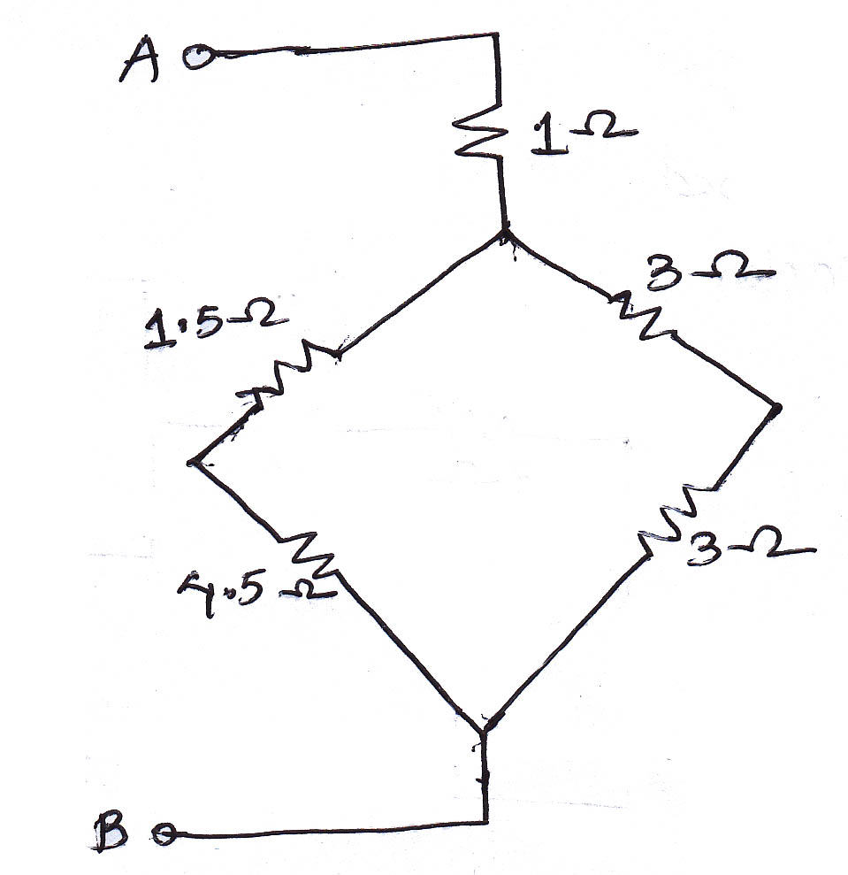
b) Find the equivalent resistance between point AB. [3]

c) Derive the expression for delta – star transformation. [8]

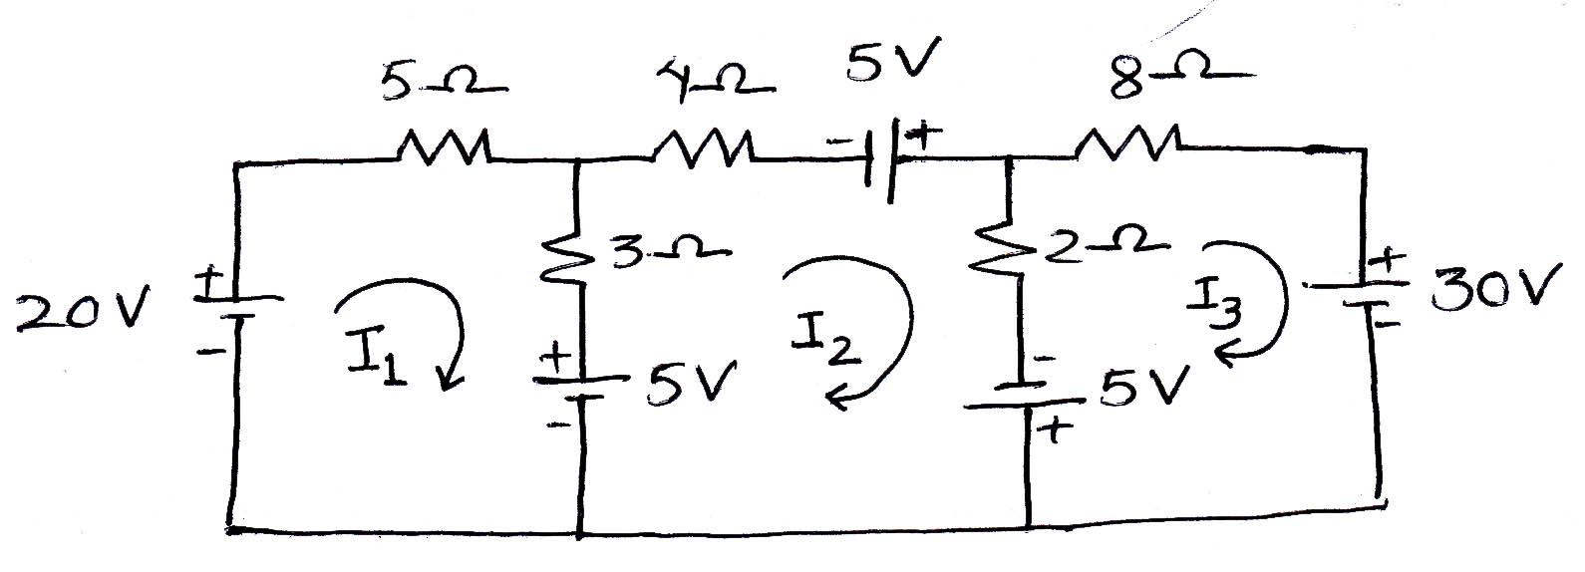
Q.2. a) Determine the current I1, I2 & I3 following circuits using loop analysis method. [8]

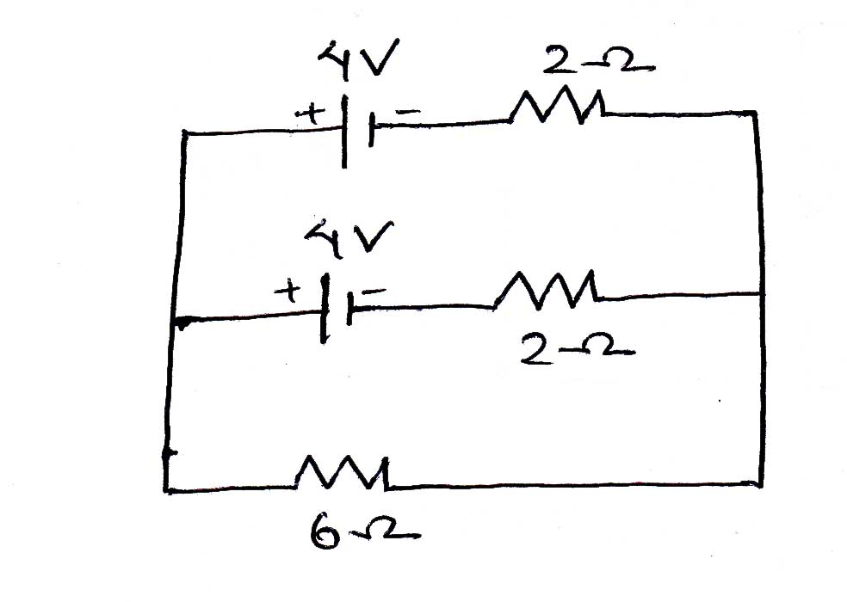
b) State superposition Theorem. Find the current in 6 Ω using superposition Theorem. [8]

Q.3. a) Define Node. Use nodal analysis to determine tha value of current 'i' in the following figure. [8]
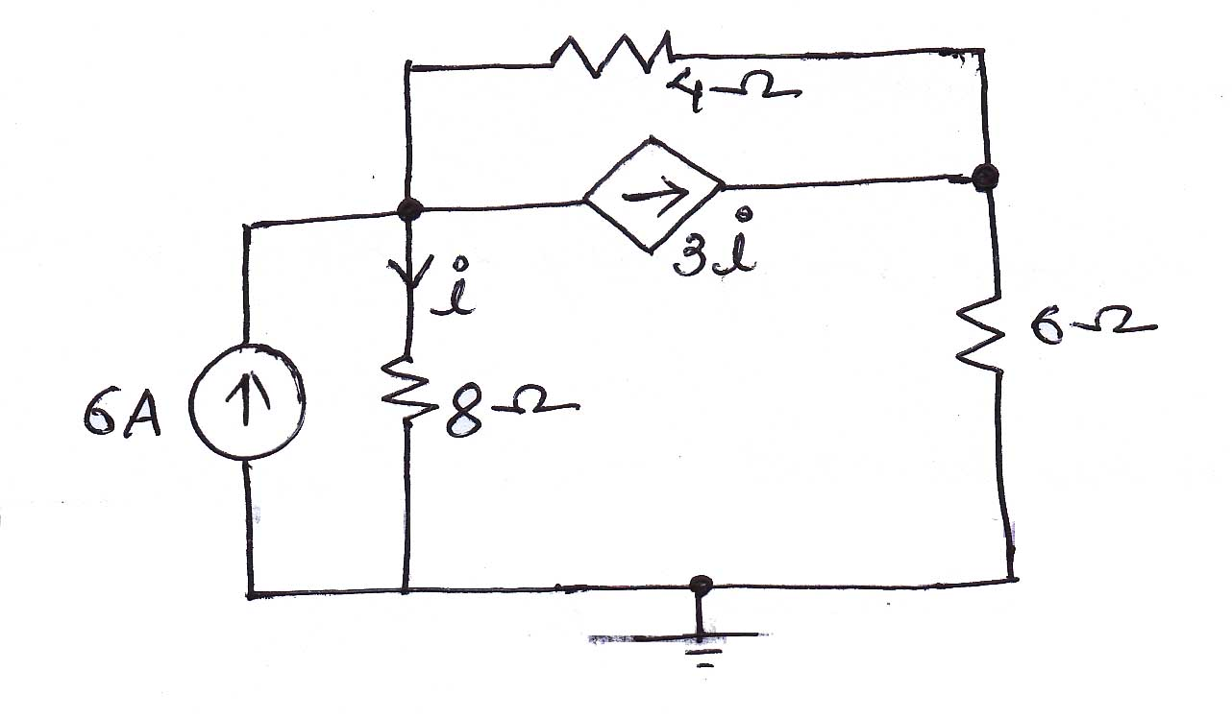

b) State Thevenin's Theorem and calculate the current flowing through 5Ω resistor using Norton's Theorem. [8]
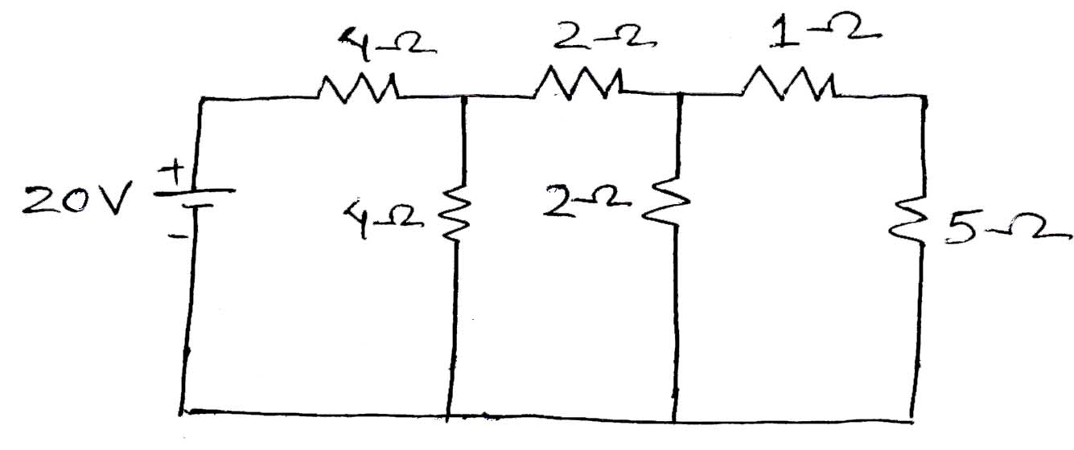

Q.4. a) Define ideal voltage source & practical current source. Use Thevenin's theorem to find current through 5Ω resistor. [8]
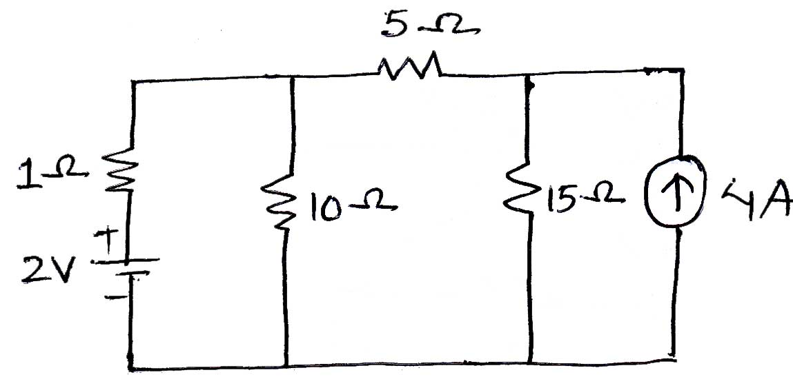

b) A series circuit consists of a resistance of 5Ω, inductor of 0.5H and capacitor of 150μF are supplied by 220V, 50Hz supply. Draw & calculate: [8]
i. Impedance of the circuit. v. Apparent power
ii. rms value of current vi. Active power
iii. Voltage drop in each element. vii. Reactive power
iv. Power factor viii. Resonant frequency.

Q.5. a) The impedance of two circuits is given by z1 = (10 + j15)Ω and z2 = (6 – j8)Ω are connected in parallel. If total voltage supplied is 220V. Then find total current, total power, power consumed by each branch. And also find the total power factor & individual power factor of each branch. Draw diagram also. [8]

b) For circuit shown in following figure,. Find: [8]
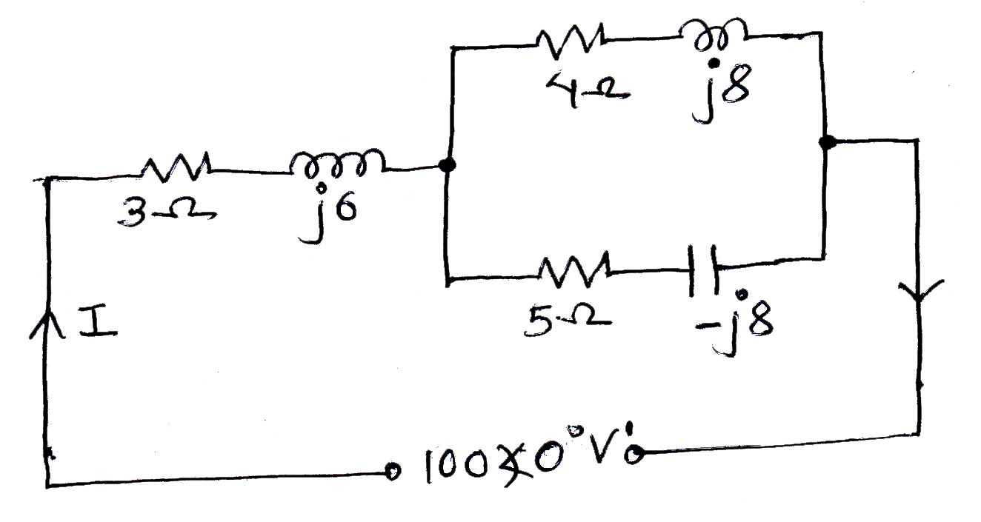
i) Total impedance
ii) Total current
iii) Total power absorbed
iv) Total power factor

Q.6. a) A 3-phase delta-connected load consume 120KW power with 1agging Line current of 200A at line voltage of 400V, 50Hz. Find power factor, phase voltage & phase impedance. But what would be power consumed if load were connected into star? [8]

b) Write short notes. (any two) [4×2= 8]
i) KCL & KVL law
ii0 Faraday's law electromagnetic Induction
iii) Generation of sinusoidal emf in single phase A-C circuit.

The End

